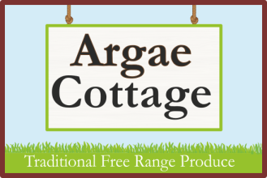
Argae Cottage
Haimwood
Llandrinio
SY22 6SQ
01691 830282
Chirstmas Produce Order Form 2019
Name:_________________________________________________
Conatact phone number:___________________________________
Email:__________________________________________________

Turkey Weight required:
4kg (£52.50)
5kg (£63.80)
6kg (£75.40)
7kg (£87.00)
8kg (£98.60)
9kg (£110.20)
10kg (£122.90)

Please send your completed form, along with your deposit of £20 to:

Argae Cottage
Haimwood
Llandrinio
SY22 6SQ

Cheques payable to C Benson please.
Or drop off in our post box with cash/cheque payment.

BACS details: Halifax sort code 11-07-01, account number 11343865 (please use your name as payment reference)

Thank you for your custom!

We will contact you to confirm your order when we receive this form.
Turkeys will be ready for collection, from our smallholding, on 22nd – 24th December.

